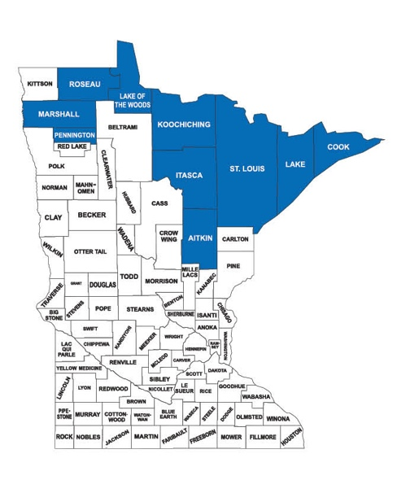
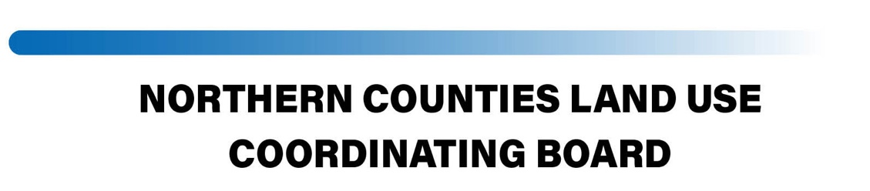
April 14, 2022
AGENDA
10:00 Call to Order: Chair Marcotte

Welcome to Kittson County Commissioner Theresia Gillie and Beltrami County Commissioner Tim Sumner.
Roll Call of NCLUCB members
Acknowledgement of other participants
Administrative Actions
Approval of the Agenda for April 14, 2022
Approval of the Minutes for February 3, 2022
Financial Report:
YTD Cash Balance $ 85,946.73
YTD Revenue $ 19,000.00
YTD Expenditures $ 1,818.75
Accounts Payable
Paul Bunyan website host $ 128.63
J.Chell Prof Ser: Feb, Mar, Ap $ 1950.50
County PILT Resolutions
Presentations and Discussions:

County/Tribal Relations and Communications: Commissioners Svaleson and Sumner.

Legislative Update: John Ongaro

Mn Land Commissioners Legislative agenda: Nathan Eide, Chair MN Assoc of Land Commissioners and Lake County Land Commissioner

404 Assumption Progress Report and WCA rulemaking: Les Lemm, BWSR Wetland Section Mgr

Congressional Action on State Mineral Development: John Eloranta and Andrew Morley, Congressman Pete Stauber’s Office.

Commissioners’ Roundtable

