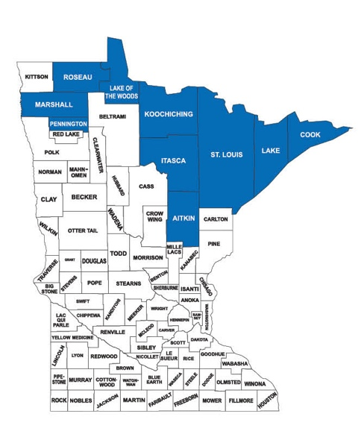

Agenda

December 2, 2021

9:50 Webex link open (see invitation for access directions)

10:00 Introduction of Participants: Chair Anne Marcotte

Administrative Actions:
Approval of the Agenda
Approval of the Minutes for October 7, 2021
Financial Report:
YTD Balance: $ 79,192.96
YTD Expenditures $ 26,843.92
YTD Revenue $ 10,000 (need resolution on 2022 dues)
Accounts Payable :
J. Chell Prof Services (Oct/Nov/Dec) $ 1650.00

  - MDNR Solicitation of Public Comments on Adequacy of Non-Ferrous Mining Regulations
(USFS Solicitation on Mineral Lease suspension and 20 yr moratorium: Jan. 19)

Opening remarks and introduction of Keith Carlson: Chair Marcotte

NCLUCB sponsored research on the Payment in Lieu of Taxes Program: Keith Carlson

Participant Questions and Comments regarding research

Potential Legislative Solutions

Next Steps

12:00 Adjourn

